|  |  |
| --- | --- |
| **NOMENCLATURE** | |
| CMOD | Crack mouth opening displacement |
| CTOD | Crack tip opening displacement |
|  | Effective crack opening displacement |
| EDM | Electrical discharge machining |
|  | Tensile strain capacity |
|  | The ratio of girth weld flaw height to pipe wall thickness |
| Extrados | Tension side of a cold bend |
| HAZ | Heat affected zone |
| Intrados | Compression side of a cold bend |
|  | The Y/T ratio of the pipe base metal |
| LVDT | Linear variable displacement transducer |
| OD | Pipe outer diameter |
| PEEQ | Equivalent plastic strain |
| SENT | Single edge notch tension |
| SMYS | Specified minimum yield stress |
| t | Pipe wall thickness |
|  | The ratio of girth weld flaw length to pipe wall thickness |
| Y/T ratio | Ratio of the yield stress to the ultimate strength |

**1 – Introduction and Literature Review**

Girth welded pipelines can be subjected to large amounts of longitudinal deformation due to a variety of conditions. In case of onshore pipelines the main causes of high longitudinal deformations are seismic activity, slope instability, frost heave and the gradual sinking of landforms to a lower level as a result of mining operations. In case of offshore pipelines the highest deformations occur in the process of pipe laying by reeling where the girth welded segments of a pipeline is wound onto a spool and therefore experiences high bending strains. Fabrication flaws in girth welds are one of the major conditions leading to the failure of a pipeline due to excessive tensile strain. In order to prevent the failure of a pipeline due to these high strain levels the inevitable fabrication flaws in the girth welds have to be kept within acceptable limits. Another load case where pipeline failure due to tensile strains can occur is the application of bending strains on cold bent pipes. Experimental studies of Sen et al. [15],[19] showed that there is a likelihood of pipe body tension side failure in load cases of cold bends under internal pressure and bending.

The lack of knowledge about the effects of flaw sizes, internal pressure and material properties on the structural behaviour of a pipeline can have detrimental economical and environmental effects. In order to understand the structural behaviour of a pipeline in the presence of fabrication flaws and internal pressure it is necessary to conduct full scale tests of the pipe for different crack sizes and internal pressure levels. The research conducted in this field in the recent years focused on pipelines with steel grades X65 and higher. Particularly the research conducted by Wang et al [1],[2],[3] lead to closed form equations which predict the tensile strain capacity of a pipeline as a function of girth weld flaw dimensions and pipe base metal mechanical properties. These equations were included in the CSA code for oil and gas pipeline systems Z662-11 [20]. However it is not recommended to apply these equations in case of pipes with steel grade X52. Also the effect of internal pressure on the tensile strain capacity is not considered in the equations given in the CSA code. In the scope of this research project a total of 8 full scale tests will be conducted at different crack dimensions and different levels of internal pressure with pipe specimens of steel grade X52 (Table 1). The outcome of this experimental study is expected to provide new insights about the acceptability of girth weld flaw sizes and structural behaviour under excessive tensile loading in case of X52 vintage pipes. Also the experimental studies of Sen et al. are further investigated using finite element analysis in order to have a better understanding of the conditions which lead to a tension side failure of cold bent pipes.

**1.1 - Weld Defects Classification and CSA Z662.11**

The Canadian Standards Association Code of Practice CSA Z662.11 [20] classifies possible weld defects as surface breaking and buried (Figure 1). Surface breaking defects are those resembling a crack that is connected to the surface of the pipe wall, whereas buried defects are those that are not connected to the surface of the pipe wall. Although the surface breaking defect is depicted in Figure 1 on the inner surface of the pipe wall, the CSA code doesn’t distinguish between surface flaws on the inner surface and those on the outer surface. According to Z662.11, in the absence of experimental data, the critical tensile strain of the pipe material () can be calculated based on Eq. (1) and Eq. (2) corresponding to the crack types depicted on the left and right side of Figure 1 respectively.

|  |  |
| --- | --- |
| surface defect | buried defect |

Figure 1: Classification of weld defects according to CSA Z662.11 as surface breaking (left) and buried (right) [20]

|  |  |  |
| --- | --- | --- |
|  | | (1) |
|  | | (2) |
|  |
|  |

Eq. (1) and Eq. (2) are developed based on the extensive experimental work conducted by Wang et al [1],[2],[3],[4],[5] on curved wide plates with machined defects. However, the code specifies high values of toughness as a limitation to using these equations, indicating that these equations were developed for modern steel pipelines. In addition, the code specifically warns that the effect of internal pressure on the longitudinal strain capacity is not considered in the equations and experienced judgement needs to be used or testing needs to be conducted to verify the behaviour under the effect of internal pressure. Thus, in order to predict the longitudinal tensile strain capacity of Enbridge X52 vintage pipeline it is imperative to conduct full scale experiments and toughness tests for a possible range of defects under the effect of both internal pressure and longitudinal tensile forces.

**1.2-Research Conducted on Tensile Strain Capacity of Pipelines using Curved Wide Plate Tests**

Due to the difficulty associated with full scale testing of pressurized pipes, full scale tests are usually conducted on curved wide plates (Figure 3) with machined defects. Wang et al. [6] developed a methodology of establishing strain based design criteria using the concept of crack tip opening displacement (CTOD). In this methodology the CTOD toughness of the pipe base metal from small scale material tests is compared to the CTOD value observed in the full scale tests. In this work CTOD of the full scale tests is also referred to as the crack driving strain. The critical strain is defined as the longitudinal strain value at the point where the CTOD in the full scale tests or finite element models reaches the CTOD toughness of the material. The location of the critical strain is chosen to be remote from the girth weld. Therefore this strain value is also called the remote strain. Wang et al [6] simulated numerous finite element models having surface defects with a variation of defect depth and weld strength mismatch ratio levels.

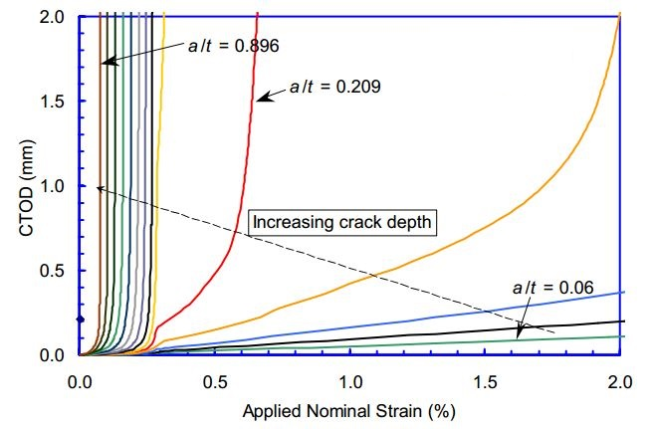

**R3**

**R2**

**R1**

Figure 2: Variation of the CTOD with respect to remote strain [6]

Figure 2 shows typical CTOD variations with respect to remote strain for different crack depth to pipe wall thickness ratios . In Figure 2 the CTOD variations are classified into the groups R1, R2, R3. These three groups are classified as unstable, stable-nonlinear and stable-linear variations of CTOD respectively. The outcome of these simulations was verified with an experimental program on curved wide plate tests performed by the University of Waterloo and the welding institute of Canada and published by Pick et al and Glover et al. [7],[8],[9]. It was concluded that the defect size is the most influential parameter affecting the tensile strain capacity. Also the results of the simulations were used to develop strain capacity prediction equations by curve fitting techniques.

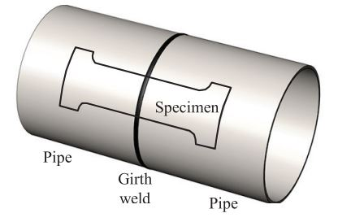

Figure 3: Position of a curved wide plate specimen [10]

In practice the remote strain in curved wide plate tests is measured using strain gauges. As a result the outcome and validity of these experiments are highly dependent on the chosen location for the strain measuring sensors. Hertele et al. [10] analyzed the effect of the remote strain sensor location in a study which includes curved wide plate tests as well as finite element simulations. In this study each side of the weld in the curved wide plate is assumed to be divided into three regions. The first of these regions is the vicinity of the weld. In order to define the boundaries of these regions a - coordinate system is introduced which has its origin at the point where a line starting from the crack center with degree angle from the plate midline intersects the plate edge. The second region is where and the third region is where . The first and third regions are assumed to have non-uniform strain distributions and the second region is divided into four partitions each being wide. The uniformity of the longitudinal strain is investigated for the second region at five different cross sections corresponding to . For each of these cross sections a dimensionless coefficient of variance is defined as the ratio of the standard deviation of the longitudinal strain along the cross section to the average longitudinal strain along the same cross section. Since changes as more deformation is applied on the specimen, another variable is defined which is the average value of over the entire test. Finally the cross section which exhibits the lowest value of is considered to have the most uniform longitudinal strain distribution.

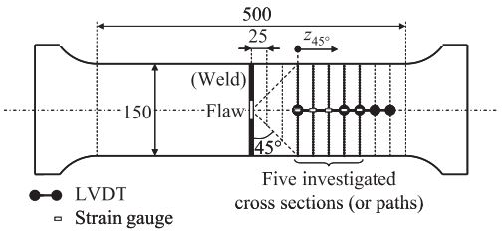

Figure 4: Division of the curved wide plate into uniform and non-uniform strain regions [10]

Wang et al [11] discussed the overview of tensile strain capacity prediction methodology developed by ExxonMobil [12]. This methodology is based on full scale tests, enrichment of strain capacity database with finite element simulations and small scale SENT (single edge notched tensile) tests for the measurement of the material CTOD toughness. Using these results and curve fitting techniques the following tensile strain capacity prediction equation is developed:

|  |  |  |
| --- | --- | --- |
|  | | (3) |
|  |

In Eq. (3) are the flaw depth, the half flaw length and pipe wall thickness respectively (Figure 1). The quantity represents the ratio of the flaw cross section area to the uncracked ligament cross section area. This dimensionless quantity provides a convenient way of visualizing the variation of the tensile strain capacity with respect to increasing flaw size (Figure 4 left). and in Eq. (3) are functions of flaw length, girth weld high – low misalignment, weld metal/ base metal strength mismatch ratio, ratio of the pipe base metal and the fracture toughness of the pipe base metal. Eq. (3) is developed for pipe grades X65 to X80. Wang et al. [13] compared the predictions of Eq. (3) with the results of full scale experiments with pressurized specimens for a variety of crack geometry and pipe material properties. The result of this comparison proved the validity of Eq. (3) (Figure 5 right).

|  |  |
| --- | --- |
|  |  |

Figure 5: Variation of tensile strain capacity with respect to flaw size (left) [11], and the validation of Eq. (3) using experimental results (right) [13]

**1.3- Research Conducted on Strain Capacity of Pressurized Pipelines**

Østby et al [14] carried out a full scale test program which included 6 pipe specimens. In these experiments a crack with 100 mm circumferential length is placed at the location of the pipe where the wall thickness was smallest. The crack depth to pipe wall thickness ratio was kept constant in all tests. Two of the experiments were carried out without internal pressure and in the remaining tests two different levels of internal pressure were tested corresponding to 25% SMYS and 60% SMYS hoop stresses. 4-point bending was applied in all tests. The steel grade was X65 for all tests. The strain measurements were made using strain gauges located 0.5 OD, 1 OD and 2 OD away from the center of the pipe. The CMOD of the flaw was measured using clip gauges with an attack point 0.2 mm below the external pipe surface. In order to measure the CTOD and crack growth (), silicone replicas of the flaws were made at different stages of the experiments. In this way the clip gauge measurements and the actual CTOD could be related to each other.

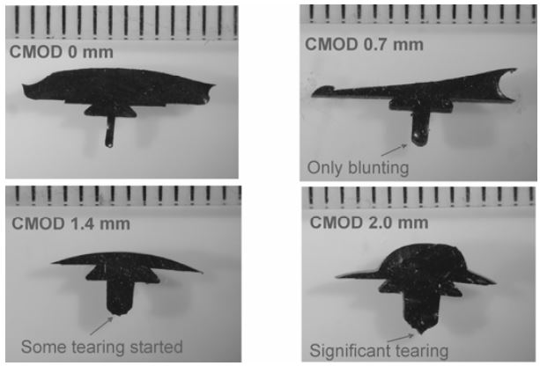

Figure 6: Silicone replicas of the flaw showing CMOD, CTOD and crack growth () at different stages of the test [14]

At the end of the experiments it was observed that the internal pressure significantly reduces the tensile strain capacity of the pipe from a level of 3.5 – 4 % to a level of 1.5 – 2%. Another observation was that the unpressurized specimens failed due to local buckling at the compression side whereas the pressurized specimens failed due to fracture at the flawed locations at the tension side. Østby et al [14] also introduced an alternative method to strain gauge measurements in order to obtain the bending strain. This method calculates the bending strain as where is the bending strain, is the outer radius of the pipe and is the radius of curvature. The comparison of the strain values calculated using this method with the average of measured strain values showed that the obtained strain values are consistent with each other.

Using the silicone replicas and numerical analysis, Østby et al [14] was able to create the crack growth resistance curves (curves showing the variation of CTOD with respect to ) of the full scale tests. The crack growth resistance curves of the full scale tests were compared to the curves obtained from small scale SENT tests. It was observed that the crack growth resistance curves obtained using these two methods are close to each other. This finding also justifies the determination of the tensile strain capacity as the strain at the point where CTOD (or CMOD) reaches the material toughness measured in the small scale tests.

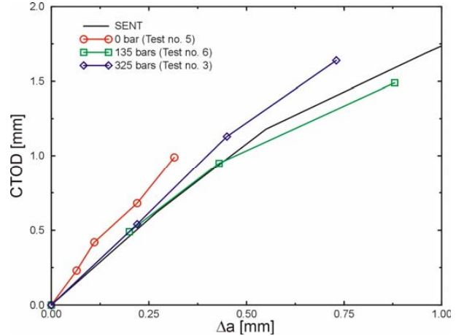

Figure 7: Comparison of the crack growth resistance curves from small scale (SENT) and full scale tests [14]

Gioielli et al [15] carried out pressurized and unpressurized full scale tests with six pipe specimens in order to investigate the effect of internal pressure on the tensile strain capacity of a pipeline. The specimens were grouped as three pairs and each pair had a different girth weld strength overmatch ratio. In each pair, one of the specimens was used for a pressurized test and the other one was used for an unpressurized test. The pressurized specimens had an internal pressure equivalent to 80% SMYS hoop stress and the unpressurized specimens had a negligible amount of internal pressure equivalent to 2% SMYS hoop stress which was applied in order to facilitate the leak detection. The girth weld strength overmatch ratios of the specimen pairs were 0%, 5% and 20%. All specimens had the steel grade X65, outer diameter of 12.75 inches (325 mm) and wall thickness of 0.562 inches (14.3 mm). Surface defects were machined on all specimens using electrical discharge machining (EDM) with equal crack dimensions of 3 mm depth and 50 mm length. Girth weld flaws were machined at three locations separated from each other at the girth weld centerline (Figure 8). The data collected in these experiments consists of the axial tensile load applied on the specimens, the overall elongation of the pipe due to axial loading, local strain measurements in longitudinal and hoop directions, crack mouth opening displacement (CMOD) and the internal pressure. The overall pipe elongation was measured using linear variable displacement transducers (LVDT). For the local strain measurements biaxial strain gauges were used at multiple locations on the pipe surface. The CMOD was measured using clip gauges. Acoustic emission monitoring was used to determine the point at which the ductile tearing of the crack initiated. The tensile strain capacities in these experiments were measured by dividing the total LVDT displacement at the moment of failure by the initial LVDT length. In the tests where the pipe failed away from the weld the tensile strain capacity was defined as the strain value at the point of maximum applied axial load. The test pairs with 0% and 5% strength overmatch exhibited tensile strain capacity decreases of 44% and 47% respectively due to internal pressure. In the tests with 20% strength overmatch the failre occurred away from the girth weld and the decrease of the tensile strain capacity due to internal pressure was 16%. The tensile strain capacities observed in this study are listed in Table 1. It was concluded that increasing girth weld strength overmatch ratio leads to a transition of the failure mode from ductile tearing at the girth weld flaw to plastic collapse away from the girth weld.

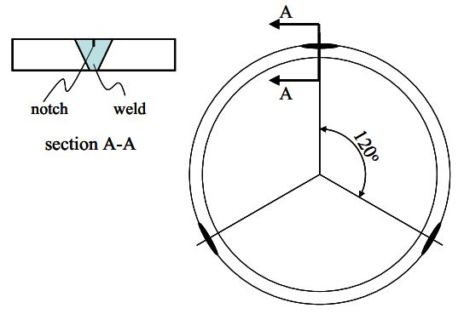

Figure 8: Placement of girth weld flaws [15]

Table 1: Measured Tensile Strain Capacities [15]

|  |  |  |  |
| --- | --- | --- | --- |
| **Girth weld strength overmatch ratio** | **Tensile Strain Capacity (%)** | | **Reduction of the tensile strain capacity due to internal pressure (%)** |
| **Pressurized** | **Unpressurized** |
| 0% | 1.9 | 3.4 | 44 |
| 5% | 1.9 | 3.6 | 47 |
| 20% | 4.6 | 5.5 | 16 |

Igi et al [16] conducted a pressurized full scale test, a curved wide plate test which represents the unpressurized load case, small scale single edge notch tension (SENT) tests as well as finite element analyses in order to develop a methodology for the prediction of the tensile strain capacity in the presence of internal pressure and surface defects. The specimens were taken from X80 pipeline with an outside diameter of 508 mm (20”) and a wall thickness of 14.3 mm (0.563”). The surface defects were machined into the heat affected zone (HAZ) of the girth weld using EDM. The SENT tests were used to determine the variation of the effective crack opening displacement () with respect to ductile crack growth (). This variation is denoted as the material resistance curve (R-curve). The finite element simulations were used to plot the variation of with respect to global strain. The global strain was calculated from the increase of axial distance between two points in the finite element models.

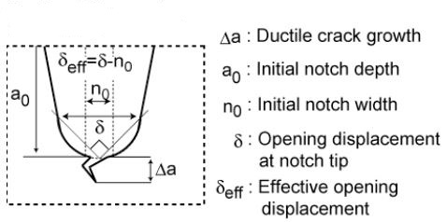

Figure 9: Longitudinal cross section of the flaw [16]

A series of finite element simulations were carried out with predefined dimensions. For each finite element simulation a curve showing the variation of with respect to global strain was plotted. In the next step on each of these curves a point was marked which shows the value that was observed in the SENT test for the corresponding level of . Once all curves are marked with a point, these points are joined which gives another curve with increasing slope. Finally the tensile strain capacity is defined as the global strain at the point where the curve which joined the marked points seems to have infinite slope. The procedure of calculating the tensile strain capacity from finite element simulations is also illustrated in Figure 10.

nd

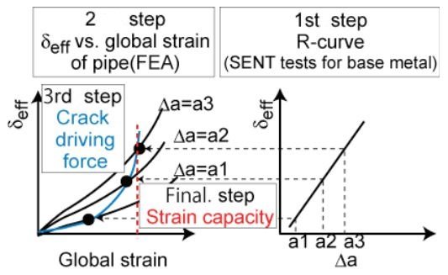

Figure 10: Calculation of the tensile strain capacity using finite element analysis and SENT tests [16]

The effect of internal pressure was investigated by comparing the results of the pressurized full scale test to the results of a curved wide plate test. It was observed that the tensile strain capacity decreases approximately 50% due to the internal pressure.

**1.4- Research Conducted on Cold Bent Pipes**

Fukuda et al [15] investigated the longitudinal strain distribution of cold bends and the decrease in the yield stress due to cold bending experimentally and numerically. Full scale cold bending experiments were carried out with two different pipes (denoted Pipe A and Pipe B in the rest of the text) of steel grade X60 and X80. The residual strains were measured using strain gauges on the line of maximum compressive strain in the longitudinal direction. It was found that the length of the longitudinal range where the compressive strain exceeds 0.2% is almost equal to the outer diameter of the pipe.

The mechanical properties of the pipes were tested before and after cold bending (Table 1).

Table 2: Mechanical properties before and after cold bending [15]

|  |  |  |  |
| --- | --- | --- | --- |
| **Pipe** | **Before and after bending** | **Yield stress [MPa]** | **Tensile Strength [MPa]** |
| A | Before | 465 | 527 |
| After | 437 | 529 |
| B | Before | 633 | 670 |
| After | 461 | 656 |

As it is shown in Table 1, due to cold bending the yield stresses of the pipe materials were reduced 6% and 27% for Pipe A (X60) and Pipe B (X80) respectively.

Caminada et al. [18] investigated the mechanical properties at extrados and intrados of cold bends. These mechanical properties are compared to those of straight pipes. Pipes with ASTM grade T23, T91 and T92 were cold bent by industrial rotary bending machines in form of U bends with a bending angle of . A total of 21 cold bends were tested with R/OD ratio ranging between 1.0 and 4.5. For the assessment of the mechanical properties, tension tests, Charpy impact tests and creep-rupture tests. The specimens for material testing were cut out of a cold bend with an outer diameter of 76 mm (3”) and a wall thickness of 12.5 mm (0.5”). Specimens were cut out of intrados, extrados and unbent portions of the pipe. The results of the tension tests showed that the yield stress at the extrados was on average 40% higher that the yield stress of the unbent pipe. On the other hand the yield stress at the intrados was on average 20% lower than the yield stress of the unbent pipe. From the results of the Charpy impact tests no correlation was observed between the locations where the test specimens were cut from and the absorbed energy in the tests. The tubes with grade T23 exhibited lower Charpy toughness than the grades T91 and T92. The results of the creep-rupture tests showed that the intrados and extrados have similar creep-rupture strength, whereas the specimens from the intrados exhibited higher creep-rupture ductility than the specimens from the extrados.

Sen et al. [19] tested one straight pipe and seven cold bend pipes under internal pressure and bending loads in order to have a better understanding of the allowable strains that a cold bend can undergo before local buckling occurs. Also the post-buckling behaviour of the cold bends were investigated. The steel grades of the specimens were X60, X65 and X80. 40%, 60% and 80% SMYS internal pressure levels were tested. In these experiments the bending load was applied in form of an eccentric compressive force which increases the curvature of the cold bend longitudinal axis. The curvature was applied after filling the pipe with water and bringing the internal pressure to the maximum level with a pneumatic pump. Both ends of the cold bends were closed with end plates welded to the pipe wall. These end plates were also connected to moment arms used for the application of the eccentric load (Figure 14). The portions of the cold bends adjacent to the end plates were prevented from ovalization. This condition was causing a stress concentration adjacent to the end plates making the pipe prone to local buckling at these locations. In order to prevent local buckling near the end plates, collars were installed at the ends of the specimen after the internal pressure was at the desired level.

The test results showed that in the post-buckling phase of the experiments, the load carrying capacity of the unpressurized specimens decreased more severely that the pressurized ones. Also the peak moments of the unpressurized specimens were less than the peak moments of the pressurized specimens. It was also demonstrated that the maximum curvature that the unpressurized specimens could undergo prior to buckling was in average 71% of the maximum curvature that the pressurized specimens could undergo prior to buckling. The comparison of the peak moments measured in two unpressurized tests showed that the effect of the OD/t ratio of the cold bend on the peak moment is greater than the effect of the yield stress of the pipe base metal on the peak moment since the specimen with lower OD/t ratio and lower yield stress exhibited higher peak moment. The comparison of the maximum moment and corresponding curvature of cold bent and straight pipes showed that these quantities are decreased due to cold bending. The average critical strain (the maximum strain prior to the formation of local buckling) of a cold bent specimen was measured as 48% of the critical strain of the straight specimen where all specimens have similar dimensions.

**2 - Problem statement:**

To date the research on pipeline structures mostly focused on the buckling of different pipe configurations under compressive forces. Such research projects were carried out to investigate the buckling and fracture of pipe walls under compressive loading. The research projects [1], [2], [3] are some examples of experimental studies which analyzed the occurrence of local buckling in the form of wrinkles in the pipe wall due to bending. On the other hand there is a limited amount of research projects studying the tensile strain capacity of pipeline that considers the effect of the internal pressure.

Different mathematical descriptions of the tensile strain capacity of pipes are available in the literature in the form of prediction equations. Some of these are incorporated in the CSA code for Pipeline Systems Operation (CSA Z662). However there is no well-established method for predicting the tensile strain capacity under internal pressure and the current equations in the CSA code don’t consider the effect of internal pressure on . Also none of the currently available methods for tensile strain capacity prediction are applicable to vintage pipes with steel grade X52. The current equations in the literature assume a steel grade of X65 or higher. These conditions make it necessary to investigate the strain response of X52 pipes under internal pressure.

Cold bending is applied in order to change the direction of a pipeline in a horizontal or vertical plane. This can be necessary to conform with the terrain conditions. Cold bending is done on site using cold bending machines. In the process of cold bending the material properties of the tension and compression side can be affected differently since the compression side (intrados) of the pipe can be loaded beyond the yield stress in compression whereas the tension side (extrados) can be loaded beyond yield stress in tension. In case of the occurrence of local buckling in form of a wrinkle at the compression side, the wrinkled part of the cold bend experiences high tensile strains and is more likely to fail due to tensile strain than the tension side. However, experimental studies carried out by Sen et al [1], [2] demonstrated that failure of a cold bend at the tension side can occur earlier than compressive failure under certain loading configurations. However, the level of internal pressure at which such failure mechanism can occur is not well understood.

Pipes may undergo tensile strain due to a variety of reasons (see section 1). These strains can be detrimental if they exceed the tensile strain capacity of the pipe. It is crucial to develop an alarm mechanism which informs the pipeline operators when there is a danger of pipeline failure due to excessive tensile strain. This alarm mechanism should be based on criteria that define the likelihood of a pipe failure. In this research project we are concerned with defining failure criteria which consider the effect of internal pressure on the tensile strain capacity of pipes. We are analyzing the effect of internal pressure on the tensile strain capacity from two different viewpoints. Firstly, we are conducting full scale tests in which we load vintage girth welded pipes with tensile forces and internal pressure in the presence of a flaw in the heat affected zone of the girth weld. By varying the amount of pressure and the flaw size we are analyzing the effect of these parameters on the tensile strain capacity of the pipe. The second viewpoint is the analysis of cold bend pipe failure at the tension side. Our initial work showed that the occurrence of this mode of failure of a cold bend highly depends on the amount of applied internal pressure.

**3- Objectives and Specific Aims**

The main objective of this research is to identify the structural behaviour of pipes under tensile strain and to define the corresponding failure criteria. In the scope of this research the strain response of X52 vintage pipes with girth weld flaws under tensile forces and internal pressure is analyzed experimentally and numerically. Also previous experimental studies carried out by Sen et al [1], [2] are revisited in order to analyze them numerically and to define tensile failure criteria. The following outlines the two main objectives of this research along with their specific aims.

**Objective 1: Evaluating the Critical Strain Capacity of X52 Pipes.**

To achieve this main objective, we are proposing an experimental and numerical research program with the following specific aims:

**Specific aim 1.1:** Assessment of the sensitivity of CSA Z662.11 tensile strain capacity prediction equations to different geometric and material parameters.

**Specific aim 1.2:** Full Scale Experiments of X52 pipe

**Specific aim 1.3:** Comparison between the different tensile strain capacity equations in the literature.

**Objective 2:** Developing generalized criteria for the tensile failure of cold bend pipes.

**Specific aim 2.1:** Numerical modelling of Sen et al experiments.

**Specific aim 2.2:** Developing a generalized model to predict the tensile failure of cold bend pipes

**Methods:**

**Objective 1: Evaluating the Critical Strain Capacity of X52 pipes.**

In order to achieve our objective, the current critical strain capacity equations available in the literature need to be studied and analyzed. Then, a full scale experimental study is designed to determine the critical strain capacity of X52 pipes with girth weld flaws under the effect of internal pressure. Following are the proposed methods to achieve our objective:

**Specific aim 1.1: Assessment of the sensitivity of tensile strain capacity prediction equations to different geometric and material parameters.** Different geometric parameters and material properties affect the tensile strain capacity of a pipe at different levels. Since our project consists of a limited number of full scale tests, it is not possible to test the effect of all parameters experimentally. Therefore it is necessary to narrow down the focus of the project to the most significant parameters affecting the tensile strain capacity. In order to achieve this, the sensitivity of the current CSA equations as well as other proposed equations in the literature should be analyzed with respect to changing magnitudes of different parameters. and factorial design techniques are applied in order to investigate this sensitivity.

**Specific aim 1.2: Full Scale Experiments of X52 pipe.** In order to investigate the critical strain capacity of X52 pipes, a full scale experimental study is proposed in which two levels of internal pressure, two different flaw heights and two different flaw lengths are combined to conduct 8 full scale tests (Table 1). Each experiment has a different combination of girth weld flaw size and internal pressure. The parameters which define the flaw size are the flaw length to pipe wall thickness ratio and the flaw height to pipe wall thickness ratio . According to the CSA code the allowable ranges for and are and . For and the flaw size is negligible according to the CSA code. Based on this information two different flaw heights (25% and 50% of the wall thickness) and two different flaw lengths (50mm and 150mm) are tested which gives us 4 different flaw size possibilities. The third variable internal pressure is in general defined as the pressure leading to a circumferential stress of a certain percentage of the specified minimum yield strength (SMYS). The CSA code stipulates that the maximum operating pressure level is the 80% SMYS. For our tests, we are proposing 2 different levels (80% SMYS and 30% SMYS). With the addition of the internal pressure as the third variable a total of 8 different test configurations result each having a different combination of flaw height, flaw length and internal pressure.

Table 3: Full Scale Test Matrix

| **Test number** | **Specimen length** | **Internal pressure (% SMYS)** | **Flaw length [mm]** | **Flaw depth [mm]** |
| --- | --- | --- | --- | --- |
| 1 | 72” | 80 | 50 | 1.7 |
| 2 | 72” | 30 | 50 | 1.7 |
| 3 | 72” | 80 | 50 | 3.4 |
| 4 | 72” | 30 | 50 | 3.4 |
| 5 | 48” | 80 | 150 | 1.7 |
| 6 | 48” | 30 | 150 | 1.7 |
| 7 | 48” | 80 | 150 | 3.4 |
| 8 | 48” | 30 | 150 | 3.4 |

**Machining the Girth Weld Flaw**

The flaws are machined in two stages using two different blades with thicknesses 0.012” and 0.006”. In the first stage the flaw is initiated with the 0.012” thick blade and cut up to a depth of 1.0 mm for the 1.7 mm deep flaw and up to a depth of 1.7 mm for the 3.4 mm deep flaw. In the second stage the blade is replaced with a 0.006” thick one and the rest of the flaw depth is cut. Before starting to cut the flaw it is checked with an L-shaped ruler that the pipe surface is perfectly perpendicular to the blade. During the flaw cutting process the pipe is located on roller stands. The circumferential length of the flaw is controlled with the rollers of the pipe stand and two magnets (G6 in Figure 1) on the pipe surface 50 mm or 150 mm apart from each other in the circumferential direction. The magnets stop the rotation of the pipe once 50 mm or 150 mm flaw length is reached. The depth of the flaw is increased in 0.05 mm steps and the depth is controlled using a dial indicator. There are two dial indicators denoted with G3 and G4 in Figure 1 showing the position of the blade in the directions parallel and perpendicular to the pipe surface respectively. G4 is brought to zero position at the beginning of the flaw cutting process once the blade touches the pipe surface and G3 is brought to zero position once the blade is aligned with the middle of the flaw location (within 5 mm distance from the girth weld). The position of the blade is adjusted using the x-y table denoted with G1 in Figure 1. An air driven motor (G2) is used to rotate the blade which is clamped between stiffeners and these stiffeners are connected to a steel block which is clamped in the x-y table. The blade-stiffener-steel block assembly is denoted with G7 in Figure 1.

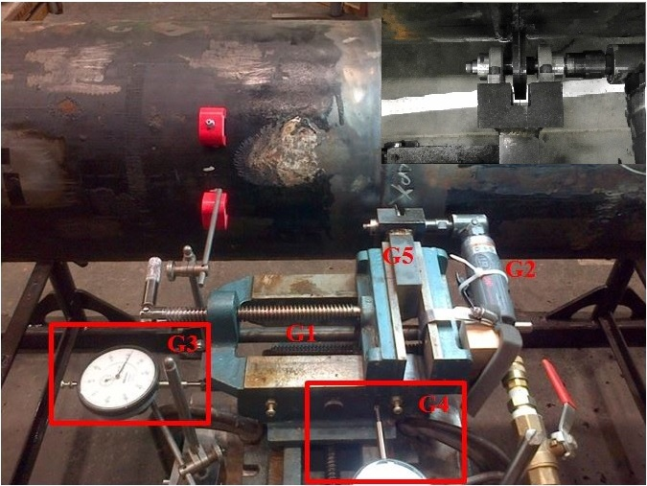

**G6**

**G7**

**G7**

Figure 11: Flaw Cutting Setup

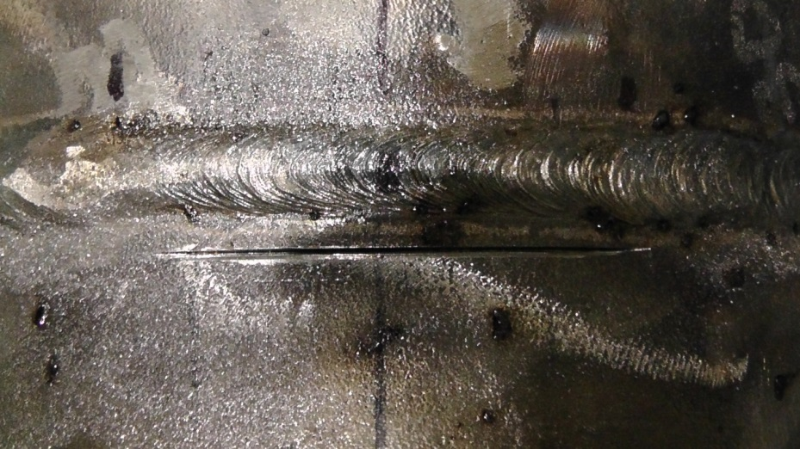

Figure 12: Flaw in the heat affected zone

**Strain Measurements**

In each full scale experiment (Table 1) the longitudinal and hoop direction strains are measured with strain gauges at critical locations of the pipe. In addition to that, digital image correlation is used to obtain the variation of the strain field during each experiment at critical locations of the pipe. The results of these measurements are used to evaluate the tensile strain capacity of each specimen. The critical tensile strain is defined in the CSA code as the value of the global compressive strain at the onset of rupture. From our tests, we are proposing the following three different options for the evaluation of the tensile strain capacity of the full scale specimen:

**Option 1:** In the literature [4] the tensile strain capacity is defined as the average axial strain value at a uniform strain zone far away from the girth weld flaw location. In this case several strain gauges are mounted on this uniform strain zone. The average value of the strain measured by these strain gauges is called the remote strain.

**Option 2:** The tensile strain capacity of the pipe can be defined as the axial strain at the uniform strain zone closest to the girth weld flaw as observed in the image correlation.

**Option 3:** As an alternative to defining the tensile strain capacity as a single number for each test specimen, the critical strain profile could be defined in the longitudinal direction of the pipe. For this purpose the strain values from the digital image correlation and the strain gauge measurements are used in combination with each other. For the first two tests three measurements can be used to create the strain profile. These measurements are the strain value at 0.8 OD away from the end plate, the strain gauge measurement in the middle of the lower side of the pipe, and a strain measurement 0.7 OD away from the flaw.

The strain is measured using strain gauges and digital image correlation. For the image correlation, portions of pipe surface around the flaw and adjacent to the lower end plate are painted in white and speckled in a dark colour before the test. This is necessary since the image correlation method uses the initial and deformed positions of the speckles to calculate the strain field at different stages of the experiment. On the remaining parts, strain gauges are glued on the pipe surface at selected distances from the end plates. At each selected distance a ring which consists of four strain gauge couples (consisting of one axial and one hoop direction strain gauge) or single strain gauges (strain gauge only in axial direction) is used. These four strain gauge positions are 90 degrees apart from each other in the circumferential direction. Putting strain gauges at different positions around the circumference is necessary since the axial strain changes around the circumference due to the eccentricity of the applied displacement. Figure 3 shows four quarters of the pipe wall cross section denoted by to . In the middle of each quarter the corresponding strain gauge location is shown with red lines and a strain gauge label. Each strain gauge label starts with the letters standing for “strain gauge”. In the strain gauge labels the numbers to denote the angular distance of the gauge location from the flaw midline in degrees. The letters at the end of each label indicate that the gauge could be in axial or hoop direction.

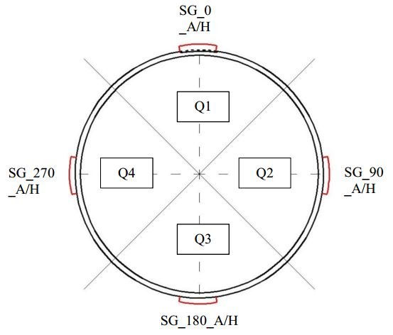

Figure 13: Strain gauge positions around the pipe circumference

**Specific aim 1.3: Comparison between the different tensile strain capacity equations in the literature.**

Several research groups have introduced equations for the prediction of the tensile strain capacity based on full scale tests and finite element analysis. These equations have certain limits of applicability in terms of flaw size limits or material property limits. A common approach is to develop a system whose input consists of flaw dimensions, pipe geometry, material properties and whose output is the tensile strain capacity of the pipe having these geometry and material properties. Our objective is to make a comparison between outputs of each equation in order to have an understanding of their applicability to different scenarios and the possibility of utilizing them for X52 pipes. The following equations are currently available in the literature for the prediction of the tensile strain capacity ([7],[4],[6]) :

|  |  |
| --- | --- |
|  | (3) |
|  | (4) |
|  | (5) |

Table 4: Nomenclature for equations (3), (4), (5)

|  |  |  |
| --- | --- | --- |
| Equation (1) |  | Crack-tip opening displacement (CTOD) toughness [mm] |
|  | Ratio of yield strength to tensile strength (Y/T) |
|  | Ratio of flaw length to pipe wall thickness |
|  | Ratio of flaw height to pipe wall thickness |
| Equation (2) |  | Fitted functions of normalized geometry and material parameters |
|  | Girth weld CTOD toughness [mm] |
| Equation (3) |  | Functions of flaw size and pipe material properties |
| A | Flaw depth |
| C | Half flaw length |
| T | Pipe wall thickness |

**Objective 2: Developing generalized criteria for the tensile failure of cold bend pipes.**

Any alarm system for the prevention of the tensile failure of cold bends needs to be implemented based on well established failure criteria. In this study we are aiming at developing such failure criteria by simulating the structural behaviour of cold bends under the combination of bending and internal pressure. Experimental studies of Sen et al [1], [3] showed that cold bends under internal pressure and closing mode bending loads can fail at the tension side after the formation of wrinkles at the compression side pipe wall. This is an unexpected mode of failure because of the large deformations at the compression side of the cold bend in the post-buckling phase.

Table 5: Geometry and Material Properties of the Cold Bend

|  |  |
| --- | --- |
| Nominal diameter | 762 mm |
| Wall thickness | 8.2 mm |
| Grade | X65 |
| Curvature | Bent 1 degree per diameter in length |
| SMYS | 448 MPa |
| Internal pressure | 80% SMYS hoop stress |

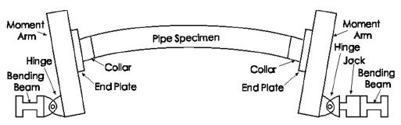

x

y

Figure 14: Experimental setup of the cold bend

**Specific aim 2.1:** **Numerical modelling of Sen et al experiments.**

In the scope of this research project, the load case and pipe geometry combination which lead to the tension side fracture of a cold bend in the experimental studies of Sen et al is simulated using finite element analysis. The objective of this simulation is to verify the outcome of the experimental studies of Sen et al and to obtain a better understanding of the conditions which lead to the tension side fracture of a cold bent pipe. Furthermore the numerical analysis of the strain distribution at the tension side of a cold bend for different load cases enables us to define failure criteria for the tension side failure mode of a cold bend pipe.

The finite element simulations are carried out for all steel grades (X60, X65, X80) tested in the experimental study of Sen[1]. In order to investigate the effect of the internal pressure level on the structural behaviour, a parametric study of the internal pressure is carried our for internal pressure values ranging between 1.93 MPa and 7.72 MPa which cause 20% SMYS and 80% SMYS hoop stress respectively. In these simulations the pipe geometry is meshed using 4-node general purpose shell elements with reduced integration (S4R). A non-linear isotropic hardening material behaviour is adopted in order to model the plastic material response. In this model, the relationship between the yield stress and the plastic strain is assumed to be non-linear between the initial yield stress and the ultimate strength. 237 mm long sections of the pipe next to the end plates are assigned a greater element thickness (16 mm) than the rest of the model (8.2 mm) in order to model the effect of the reinforcing collars (Figure 1) and to prevent an inappropriate buckling of the model due to the pipe - end plate interaction. The moment arm (Figure 1) is modeled using rigid beam and multi point constraints. The nodes on the left pipe edge (Figure 2, Figure 3) are connected to a reference point at the centroid of the cross section of the pipe edge using multi-point constraints. This reference point, on the other hand, is connected to another reference point 600 mm below in y-direction with rigid beam constraints. In the setup of Figure 1, the jack on the right hand side applies the displacement. This jack is connected to the moment arm with a pin-yoke assembly which is denoted as “hinge” in Figure 1. In the rest of this text this right hand side hinge is referred to as the “loading pin”. In the finite element model, the reference point located 600 mm below the pipe axis represents the loading pin.

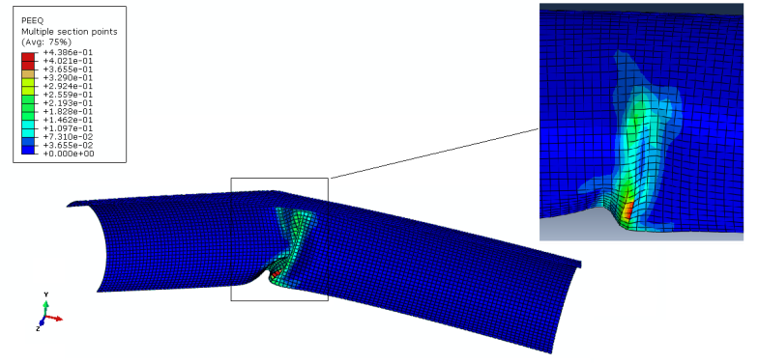

Figure 15: Plastic strain distribution under bending load without internal pressure

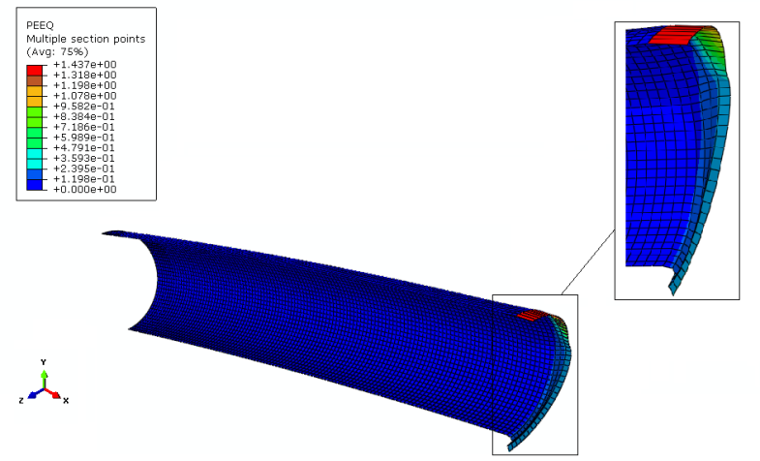

Figure 16: Plastic strain distribution under bending load and internal pressure

In order to increase the computational efficiency of the model, symmetry conditions are introduced. For this purpose symmetry planes parallel to x-y and y-z planes are introduced and one quarter of the entire cold bend pipe is simulated. As the first step of the simulations, internal pressure is applied on the inner surfaces of the pipe wall. In the parametric studies of the effect of internal pressure, the pressure value is varied between 1.93 MPa and 7.72 MPa which correspond to 20% SMYS and 80% SMYS hoop stress respectively. In the next step of the simulations a displacement load of 298.99 mm is applied to the loading pin in x-direction causing the closing mode bending stresses and increasing the initial curvature of the cold bend.

**Specific aim 2.2:****Developing a generalized model to predict the tensile failure of cold bent pipes**

The finite element simulations showed that the failure of a cold bent pipe at the tension side is limited to load cases with internal pressure. Furthermore the amount of internal pressure is a decisive factor for the failure mode. In order to define a failure criterion, the variation of the equivalent plastic strain with respect to applied curvature is plotted for different levels of internal pressure. These plots have revealed that starting from a certain level of internal pressure, the equivalent plastic strain at the compression side stays below 40% whereas the equivalent plastic strain at the tension side starts to exceed 40%. This internal pressure level is denoted as **transition pressure** in this text and can slightly change with respect to the steel grade of the pipe. Also for internal pressure levels below the transition pressure, the equivalent plastic strain at the compression side can exceed 40% whereas at the tension side it stays below 40%.

**4- Progress to Date**

**4-1 Sensitivity Analysis of the Tensile Strain Capacity Prediction Equations**

The tensile strain capacity prediction equations currently available in the CSA code (Eq. (1), (2)) are studied. Eq. (1) and Eq.(2) are analyzed using and factorial design respectively. The purpose of that study is to determine the parameters having the greatest effect on the tensile strain capacity of a pipe in the presence of girth weld flaws and to analyze the sensitivity of the prediction equations to the variations of the different parameters (flaw dimensions and material properties). In the notation for factorial designs, the base denotes that the tensile strain capacity is evaluated at different levels (low, intermediate, high) of each parameter affecting the tensile strain capacity, and denotes the total number of parameters. In case of surface defects is equal to and in case of buried defects is equal to . The geometry of factorial design can be visualized as in Figure 17.

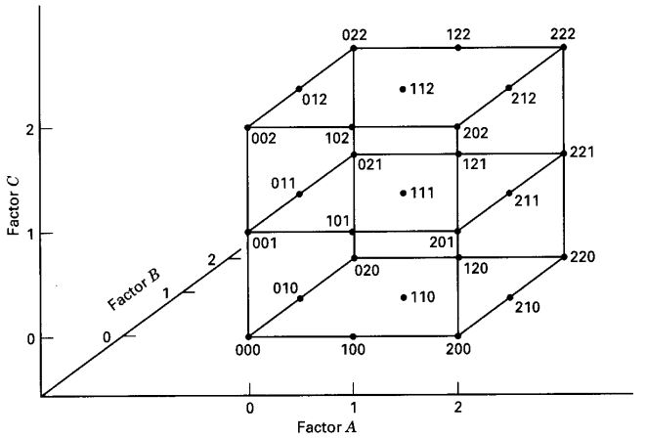

Figure 17: Combinations of three parameters (Factor A, Factor B, Factor C) at three different levels (0, 1, 2) [25]

In Figure 17 each of three coordinate axes represents a different parameter. The three digit numbers at the corners and side mid-lengths of the cube represent the combinations of the parameters for which the output quantity is evaluated. In each three digit number the first second and third digits denote the levels of the parameters Factor A, Factor B and Factor C respectively. The digits represent the low, intermediate and high levels respectively.

In case of surface defects, the parameters affecting the tensile strain capacity are defect height, defect length, the ratio of yield stress to ultimate strength of the pipe base metal and the CTOD toughness of the pipe base metal such that . In the factorial design, is evaluated at all combinations of the four parameters at the low, intermediate and high levels which gave different predictions for . In order to determine the sensitivity of to the changes in a particular parameter, is evaluated when this parameter is kept fixed at low, intermediate and high levels for all possible combinations of the rest of the parameters. This analysis gives 27 different predictions for each fixed level of the parameter. The next step of the analysis is to take the average of the 27 predictions for each level which gives a single real number for each level of the parameter. The final step of the analysis is to plot the variation of these averages with respect to the level at which the parameter is fixed and to repeat this procedure for all of the parameters.

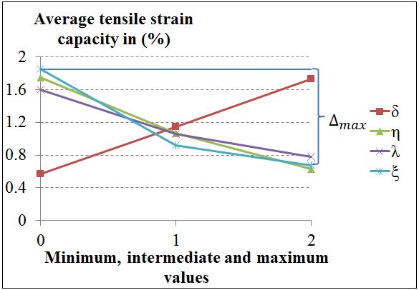

Figure 18: Sensitivity analysis for surface defects

Figure 18shows the result of the factorial design for surface defects. For the analysis in Figure 18, the parameters are fixed in low, intermediate and high levels. These levels are assigned based on the acceptability boundaries for these parameters defined by the CSA code [24]. In Figure 18, is the maximum difference between the highest and the lowest value exhibited by a parameter. A high value of for a parameter indicates that the prediction equation is highly sensitive with respect to this parameter. In case of the surface defect the highest value was observed for the variation of the parameter . Table 6 shows a list of the maximum differences in predicted values for the case of surface defect. Figure 18 also shows that the variations of with respect to and are close to linear whereas the variations with respect to and are non-linear.

Table 6: Differences between the highest and lowest predicted

|  |  |  |  |  |
| --- | --- | --- | --- | --- |
|  |  |  |  |  |
|  | 1.18 | 1.16 | 1.12 | 0.82 |

For the case of buried defects the same procedure is applied with the difference that this time two additional parameters, wall thickness (t) and the ratio of defect depth (measured from internal pipe surface) to pipe wall thickness (), are also included in the factorial design. The addition of these parameters increased the number of total evaluations of from 81 to 729 and the number of evaluations for each fixed value of each parameter from 27 to 243.

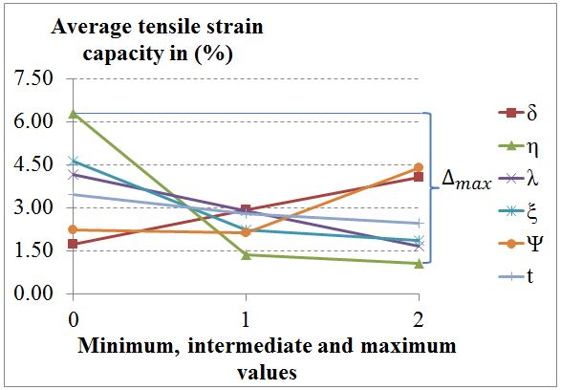

Figure 19: Sensitivity analysis for buried defects

Figure 19shows the result of the factorial design for buried defects. According to Figure 19 the variations of with respect to , and are close to linear whereas the variations with respect to , and are non-linear. Table 7 shows a list of the maximum differences in predicted values for the case of buried defect.

Table 7: Differences between the highest and lowest predicted

|  |  |  |  |  |  |  |
| --- | --- | --- | --- | --- | --- | --- |
|  |  |  |  |  |  | **t** |
|  | 5.25 | 2.77 | 2.52 | 2.35 | 2.28 | 0.99 |

**4-2 Full Scale Tensile Strain Experiments**

As it is shown in Table 3 a total of 8 full scale tests are planned to be carried out in this research program. The first two of these experiments are accomplished. In this section the results of these two experiments will be demonstrated.

Tensile strain data is collected using strain gauges and digital image correlation. In the first two tests the image correlation and strain gauge methods are applied on separate parts of the pipe surface. In the following tests it is planned to apply both methods over the entire tension side of the pipe surface. Figure 20, Figure 21, Figure 22, Figure 23 show the positions of the strain gauges and the painted areas for the image correlation. For each test the bottom and top sides of the specimen are shown separately for the sake of clarity. The locations of the longitudinal and hoop direction strain gauges are marked with purple and green respectively. For both tests both the top and the bottom parts of the specimens have a ring of strain gauges 1.5 OD away from the end plates. For both tests the main difference in the locations of the strain gauges between the top and bottom parts of the specimen is that in the bottom part there is a ring of strain gauges 1 OD away from the girth weld flaw whereas in the top part there is a ring of strain gauges 1 OD away from the top end plate. The reason for this is the different positions of the speckled areas at the top and bottom parts. On the top side of the girth weld the only image correlation area was adjacent to the girth weld due to the height limitation of the camera system. The longitudinal strain values on the top part of the specimen close to the top end plate are measured using the ring of strain gauges 1 OD away from the top end plate.

Table 8and Table 9 show the cross correlation coefficients between the strain gauge measurements of test 1 and test 2 respectively.The values inTable 8andTable 9are calculated using the **“***corrcoef*” function in Matlab.In order to use the limited place effectively inTable 8 and Table 9only the strain gauges having good correlation (greater than 0.9) with the other strain gauges are listed. Also the cross correlation between any two gauges is shown only once and the cross correlation values less than 0.9 are not shown in the tables for the sake of clarity. The cross correlation values are calculated using the data up to the first strain gauge failure during the test. The positions of all strain gauges listed in Table 8 are shown in Figure 20 and Figure 21 whereas the positions of the gauges listed in Table 9 are shown in Figure 22 and Figure 23. From Table 8 it is clear that the strain gauges 4, 10, 12, 16, 22, 24 have good correlation with at least six other strain gauges whereas the strain gauges 1, 5, 15, 18, 21 have no correlation with any of the strain gauges in test 1. The measurements of these two groups of strain gauges are plotted separately in Figure 24 and Figure 25. From these plots it can be concluded that the strain gauges having no correlation with any other strain gauge also appear to have made erroneous measurements. On the other hand strain gauges having good correlation with a large number of the other gauges appear to have made reliable measurements.

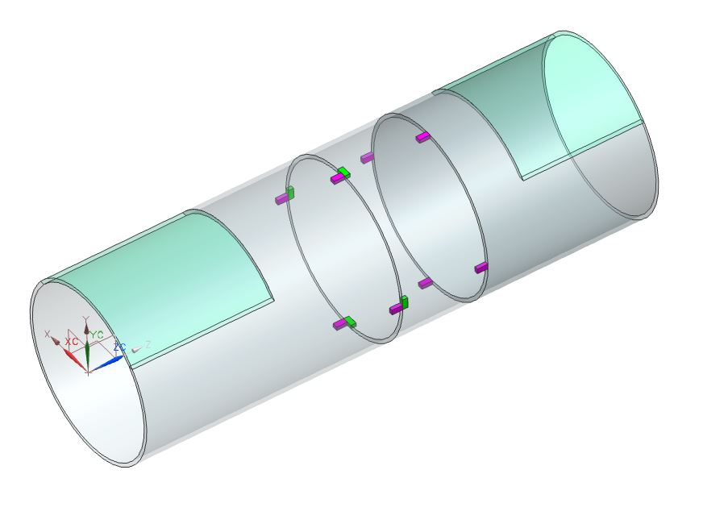

End Plate Side

Girth Weld Side

12

11

10

9

7

6

5

1

4

3

2

1 OD

2 OD

5/6 OD

1.5 OD

Speckled Areas

17/24 OD

8

Figure 20: Bottom side of the pipe in the first test

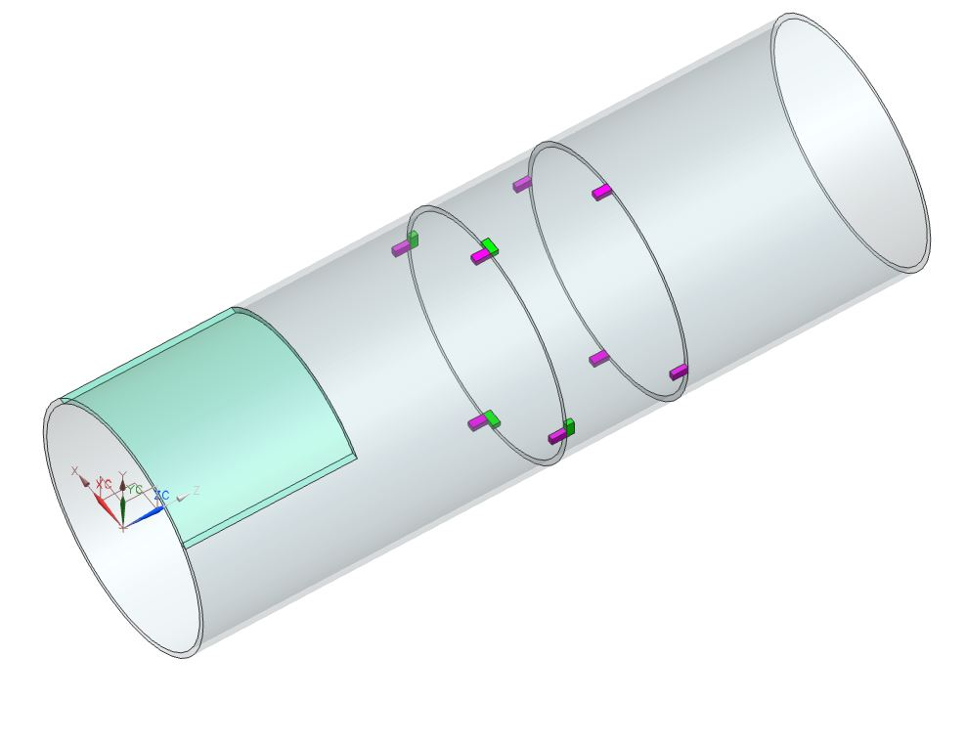

2 OD

1 OD

End Plate Side

22

20

24

23

21

19

18

17

16

15

14

13

17/24 OD

Girth Weld Side

1.5 OD

Speckled Area

Figure 21: Top side of the pipe in the first test

Table 8: Cross correlation of strain gauge measurements from Test 1

|  |  |  |  |  |  |  |  |  |  |  |  |  |  |
| --- | --- | --- | --- | --- | --- | --- | --- | --- | --- | --- | --- | --- | --- |
| Gauge No  Gauge No | 8 | 9 | 10 | 11 | 12 | 14 | 16 | 17 | 19 | 20 | 22 | 23 | 24 |
| 2 |  | **0.92** |  |  |  |  |  |  |  |  |  |  |  |
| 3 |  |  |  | **0.99** |  |  |  |  |  |  |  | **0.99** |  |
| 4 |  |  | **0.93** |  | **0.99** | **0.99** | **0.99** |  |  |  | **0.98** |  | **0.99** |
| 6 | **0.96** |  |  |  |  |  |  |  | **0.97** |  |  |  |  |
| 7 |  |  |  |  |  |  |  |  |  | **0.91** |  |  |  |
| 8 |  |  |  |  |  |  |  |  | **0.95** |  |  |  |  |
| 9 |  |  | **0.92** |  |  |  |  |  |  |  | **0.90** |  |  |
| 10 |  |  |  |  | **0.90** | **0.93** | **0.96** |  |  |  | **0.98** |  | **0.94** |
| 11 |  |  |  |  | **0.91** |  |  |  |  |  |  | **0.99** |  |
| 12 |  |  |  |  |  | **0.99** | **0.97** |  |  |  | **0.96** | **0.90** | **0.99** |
| 13 |  |  |  |  |  |  | **0.99** | **0.97** |  |  |  | **0.96** | **0.90** |
| 14 |  |  |  |  |  |  | **0.99** |  |  |  | **0.98** |  | **0.99** |
| 16 |  |  |  |  |  |  |  |  |  |  | **0.99** |  | **0.99** |
| 22 |  |  |  |  |  |  |  |  |  |  |  |  | **0.99** |

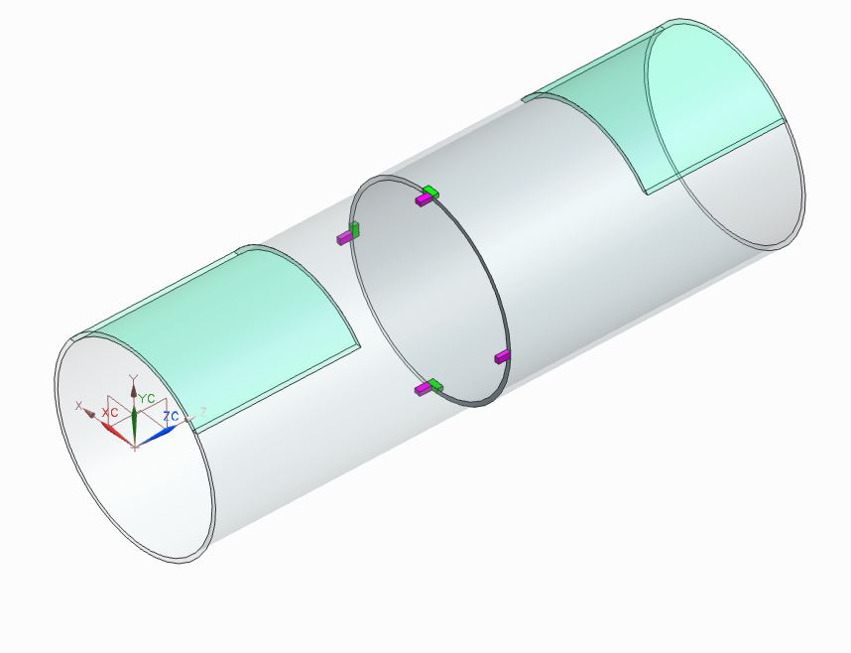

17

16

15

14

4

3

1

17/24 OD

5/6 OD

1.5 OD

Speckled Areas

1.5 OD

Figure 22: Bottom side of the pipe in the second test

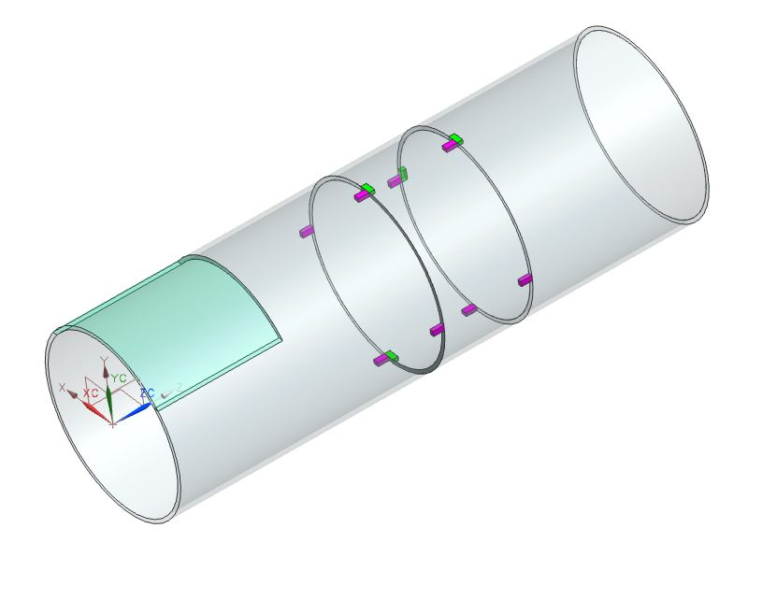

19

18

13

12

11

10

9

8

7

6

5

2

17/24 OD

1 OD

2 OD

1.5 OD

Speckled Area

Figure 23: Top side of the pipe in the second test

Table 9: Cross correlation of strain gauge measurements from Test 2

|  |  |  |  |  |  |  |  |  |  |  |  |  |  |  |  |  |
| --- | --- | --- | --- | --- | --- | --- | --- | --- | --- | --- | --- | --- | --- | --- | --- | --- |
| Gauge No  Gauge No | 2 | 3 | 4 | 5 | 7 | 9 | 10 | 11 | 12 | 13 | 14 | 15 | 16 | 17 | 18 | 19 |
| 1 | **0.91** |  | **0.91** | **0.93** |  |  |  |  |  |  |  |  |  |  | **0.94** |  |
| 2 |  | **0.95** | **0.99** | **0.99** |  |  |  |  |  |  |  |  |  |  | **0.99** | **0.90** |
| 3 |  |  | **0.95** | **0.91** |  |  |  |  |  |  |  |  |  |  |  | **0.99** |
| 4 |  |  |  | **0.99** |  |  |  |  |  |  |  |  |  |  | **0.99** | **0.90** |
| 5 |  |  |  |  |  |  |  |  |  |  |  |  |  |  | **0.99** |  |
| 6 |  |  |  |  | **0.99** | **0.99** | **0.99** | **0.99** |  | **0.99** | **0.99** | **0.99** |  | **0.99** |  |  |
| 7 |  |  |  |  |  | **0.99** | **0.99** | **0.99** |  | **0.99** | **0.99** | **0.99** |  | **0.99** |  |  |
| 8 |  |  |  |  |  |  |  |  | **0.96** |  |  |  | **0.96** |  |  |  |
| 9 |  |  |  |  |  |  | **0.99** | **0.99** |  | **0.99** | **0.99** | **0.99** |  | **0.99** |  |  |
| 10 |  |  |  |  |  |  |  | **0.99** |  | **0.99** | **0.99** | **0.99** |  | **0.99** |  |  |
| 11 |  |  |  |  |  |  |  |  |  | **0.99** | **0.99** | **0.99** |  | **0.99** |  |  |
| 12 |  |  |  |  |  |  |  |  |  |  |  |  | **0.99** |  |  |  |
| 13 |  |  |  |  |  |  |  |  |  |  | **0.99** | **0.99** | **0.91** | **0.99** |  |  |
| 14 |  |  |  |  |  |  |  |  |  |  |  | **0.99** |  | **0.99** |  |  |
| 15 |  |  |  |  |  |  |  |  |  |  |  |  |  | **0.99** |  |  |
| 16 |  |  |  |  |  |  |  |  |  |  |  |  |  | **0.91** |  |  |

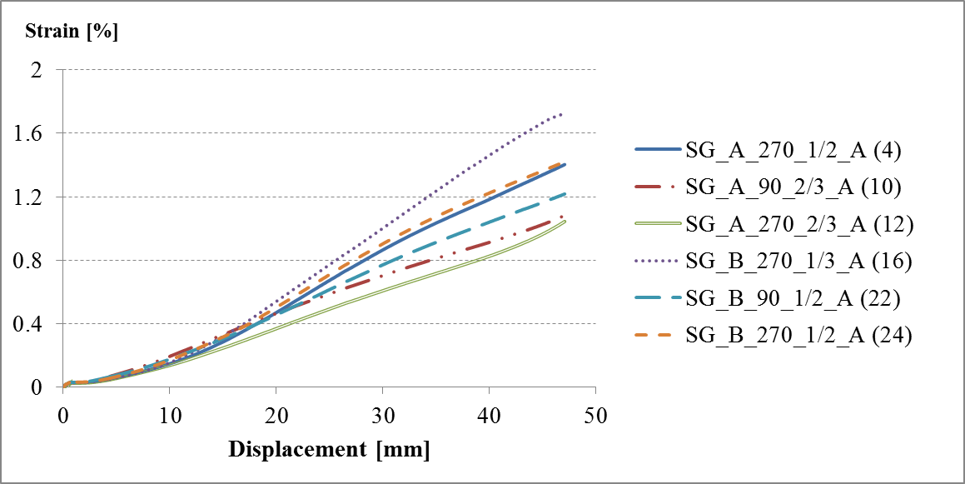

Figure 24: Measurements of the strain gauges with good correlation (Test 1)

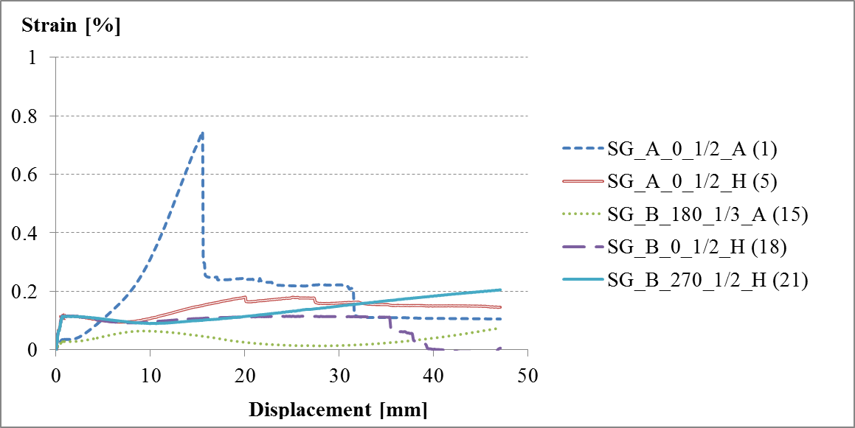

Figure 25: Measurements of the strain gauges with no correlation (Test 1)

The information from Figure 24 and Figure 25 about the reliability of the strain gauge measurements is used in order to visualize the variation of the longitudinal strain along a half-length of the pipe. This strain variation is denoted as the “strain profile” in the rest of this section. For the strain values near the end plate and near the girth weld the digital image correlation results are used. For the longitudinal strain in the middle of one side of the specimen the strain gauge 1.5 OD away from the end plate or the strain gauge 2 OD away from the end plate is used. For the strain profile of the bottom side of Test 1, the strain gauge 1.5 OD away from the end plate is the gauge number 1 (Figure 20) which is assumed to be unreliable according to the cross correlation analysis. Therefore for the middle strain value of the bottom side of the first specimen, the strain gauge 2 OD away from the bottom end plate is used. This strain gauge has the number 9 in Figure 20.

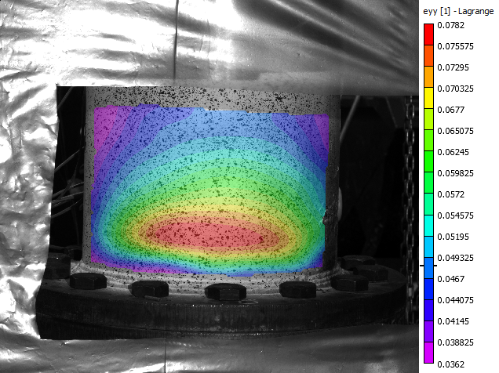

Figure 26: Digital image correlation showing the critical strain distribution close to the bottom end plate (Test 1)

However the measurements from gauge number 9 have a sudden drop towards the end of the test from 1.6 % to 1 %. Also according to Table 8, gauge 9 is highly correlated to only gauge 2 which shows a sudden strain drop from 1.2 % to 0.6 % towards the end of the test. This indicates that the measurements from gauge 9 are unreliable at the late stages of the test. Therefore in order to obtain the critical strain profile that occurs right before the pipe rupture an extrapolated strain value is adopted instead of the actual strain measured by gauge 9. The extrapolated value is calculated based on the ratio between the strain gauge measurement and the image correlation strains in the earlier stages of the test. Table 10 and Table 11 demonstrate the steps of calculating the extrapolated strain value for the frames 1300 and 1382. In Table 10 the extrapolated strain values at the gauge 9 location are coloured in red. The frame numbers in Table 10 and Table 11 denote the different stages of the test. During experiments, all data is recorded every 10 seconds and each frame represents one sample of recordings. The first test consists of 1457 frames in total and frame 1382 is the frame closest to the pipe rupture. In Table 10 and Table 11 “remote strain measurement” denotes the strain measured by the image correlation close to the bottom end plate. From Figure 26 it is clear that adjacent to the end plate there is a strain concentration. This condition is caused by the constraints put on the pipe by the end plate and doesn’t correspond to the usual operating conditions of the pipe. Therefore for the remote strain measurements the longitudinal strain value farthest away from the end plate is chosen in Figure 26 in order to minimize the effect of the end plate on the strain profile. The location of the girth weld side strain measurements in Table 10 is the uniform strain zone closest to the surface defect.

Table 10: Development of the strain profile in Test 1

|  |  |  |  |
| --- | --- | --- | --- |
| **Frame** | **Remote strain measurement %** | **Gauge 9 reading** | **Girth weld side strain measurement (%)** |
| 600 | 0.0477 | 0.03115 | 0.03566 |
| 800 | 0.2496 | 0.22352 | 0.2265 |
| 1000 | 0.6781 | 0.68817 | 0.6731 |
| 1200 | 2.099 | 1.31304 | 1.44583 |
| 1300 | 3.4 | 2.09108 | 1.86875 |
| 1382 | 4.8013 | 2.83762 | 2.39687 |

Table 11: Ratio between strain gauge measurement and the image correlation strains

|  |  |  |  |  |  |
| --- | --- | --- | --- | --- | --- |
| **Frame** | **Increase in the remote strain (%)** | **Ratio(left/right)** | **Increase in the gauge 9 reading** | **Ratio (left/right)** | **Increase of the crack side strain (%)** |
| 800 | 0.2019 | 1.04954 | 0.19237 | 1.008017 | 0.19084 |
| 1000 | 0.4285 | 0.922199 | 0.46465 | 1.040417 | 0.4466 |
| 1200 | 1.4209 | 2.273938 | 0.62486 | 0.808644 | 0.77273 |
| 1300 | 1.301 | NA | NA | NA | 0.42292 |
| 1382 | 1.40125 | NA | NA | NA | 0.52812 |
|  | Average | **1.415226** |  | **0.952359** |  |

In Table 11 the columns denoted with “ratio (left/right)” show the ratios between the increases in the image correlation strains and the increases in the gauge 9 readings. Since the gauge 9 readings are not reliable for frames 1300 and 1382 they are not included in Table 11. The gauge 9 readings in Table 10 for the frames 1300 and 1382 are calculated using the average of the strain values calculated using the strain increase ratios in the last row of Table 11. Eq. (6) demonstrates this calculation for frame 1300:

|  |  |
| --- | --- |
|  | (6) |

In Figure 27 the strain profiles at different stages of the first test are demonstrated using different colours. The labels “remote”, “gauge”, “crack” for the horizontal axis of Figure 27 denote the locations of the “remote strain measurement”, “gauge 9” and “girth weld side strain measurement” respectively. Since adjacent to the top end plate no image correlation was applied, the strain profiles are only generated for the bottom parts of the specimens.

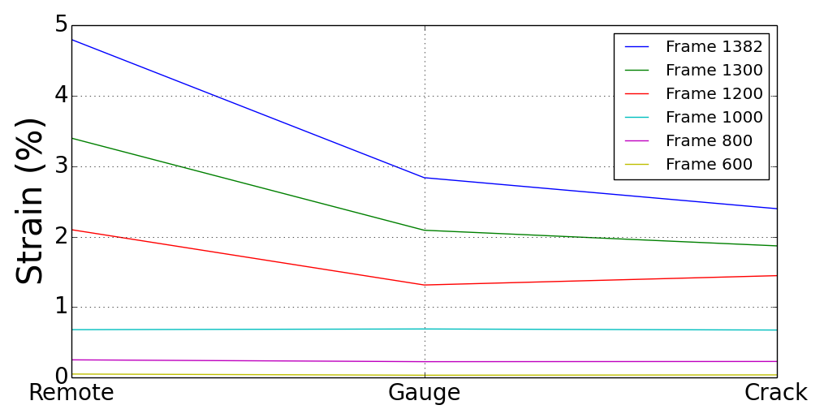

Figure 27: Development of the strain profile at the bottom side of Specimen 1

**Analysis of Test 2**

According to Table 9 in test 2 all strain gauges were highly correlated to at least two other strain gauges. Gauges number 2, 4, 6, 7, 9, 10, 11, 13, 14, 15, 17 are correlated to at least 6 other strain gauges. The gauges 8 and 12 are only correlated to each other and gauge 16. Although the gauges 8, 12 and 16 are not correlated to a large number of the rest of the gauges, Figure 22 and Figure 23 show that all of these three gauges are longitudinal gauges away from the surface defect. Since this part of the specimen experiences relatively low levels of strain during the test it is these strain gauges are expected to measure strains uncorrelated with the rest of the gauges. Therefore it can be assumed that the measurements of gauges 8, 12, 16 are reliable in the second test.

In the second test gauge 14 is aligned with the mid-line of the surface defect on the tension side of the specimen 1.5 OD away from the bottom end plate. According to Table 9, gauge 14 is highly correlated with 8 other strain gauges. Therefore gauge 14 is assumed to have made reliable measurements and it is used for the strain profiles of the second test. However for this strain gauge erroneous measurements were observed starting from frame 1592. Therefore the gauge strain values of the strain profiles for frame 1600 and frame 1700 in Figure 28 are extrapolated values calculated using the same method as in test 1. In test 2 a total of 1818 data frames are recorded and the pipe rupture occurred around the frame 1700.

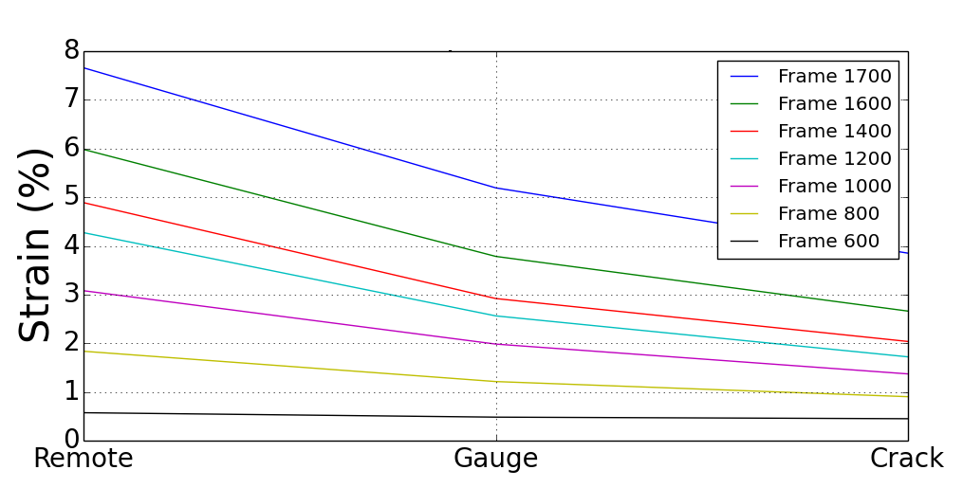

Figure 28: Development of the strain profile at the bottom side of Specimen 2

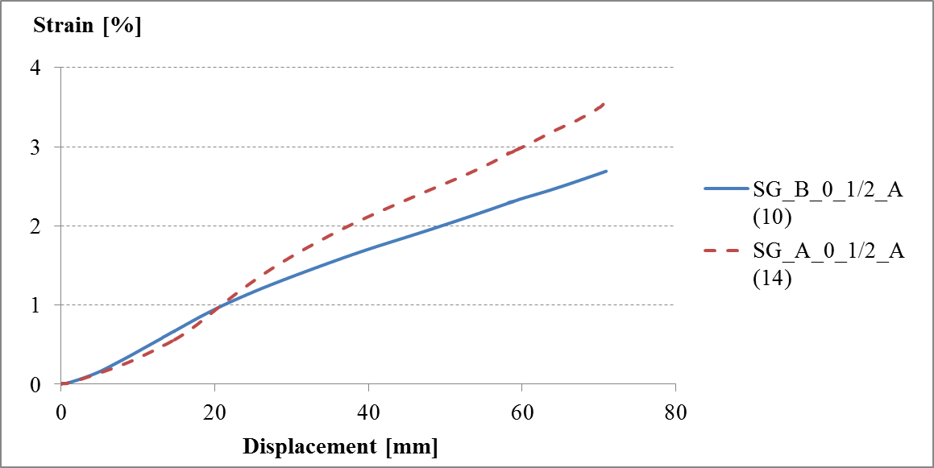

Figure 29: Comparison of bottom and top side mid-length longitudinal strain values

In order to investigate the difference between the tensile strain values at the top and bottom halfs of the specimen, the strain measurements of gauge 10 (top side) and gauge 14 (bottom side) are plotted in Figure 29. According to the cross correlation analysis, gauge 10 has good correlation with 8 other strain gauges. Therefore gauge 10 measurements are assumed to be reliable. Figure 29 shows that higher strain values are recorded at the bottom side of the specimen.

**5- Schedule**

**6- Publications**

**References**

[1] Wang Y.Y., Chen Y. (2005), “Reliability Based Strain Design. Gas Research Institute Report 04/0146”, Des Plaines, IL.

[2] Wang Y.Y., Cheng W. (2004),”Guidelines on Tensile Strain Limits. Gas Research Institute Report 04/0030”, Des Plaines, IL.

[3] Wang Y.Y., Cheng W., Horsley D. (2004),”Tensile Strain Limits of Buried Defects in Pipeline Girth Welds ”, Proceedings of IPC2004, International Pipeline Conference, IPC2004-524

[4] Wang Y.Y. et al (2004), “Tensile Strain Limits of Girth Welds with Surface-Breaking Defects Part I – An Analytical Framework”, Proceedings of the 4th International Conference on Pipeline Technology, 235-249.

[5] Wang Y.Y. et al (2004), “Tensile Strain Limits of Girth Welds with Surface-Breaking Defects Part II – Experimental Correlation and Validation”, Proceedings of the 4th International Conference on Pipeline Technology, 251-266.

[6] Wang Y.Y., Rudland D., Denys R., Horsley D. (2002), “A Preliminary Strain Based Design Criterion for Pipeline Girth Welds”, Proceedings of 4th International Pipeline Conference, Calgary, IPC2002-27169

[7] Pick R. J., Glover A. G., Coote R.I. (1980),”Full Scale Testing of Large Diameter Pipelines”, Pipeline and Energy Plant Piping, Pages 357-366, DOI: 10.1016/B978-0-08-025368-8.50042-7

[8] Glover A.G., Coote R.I., Pick R.J. (1981), “Engineering Critical Assessment of Pipeline Girth Welds”, Proceedings of Conference on Fitness for Purpose Validation of Welded Construction, The Welding Institute

[9] Glover A.G., Coote R.I. (1984), “Full Scale Fracture Tests of Pipeline Girth Welds “, Circumferential Cracks in Pressure Vessels and Piping-Vol.2, PVP Vol.95

[10] Hertele S., de Waele W., Denys R., Verstraete M. (2012), “Investigation of Strain Measurements in (curved) wide plate specimens using digital image correlation and finite element analysis”, The Journal of Strain Analysis for Engineering Design, DOI:10.1177/0309324712445121

[11] Wang X., Kibey S., Tang H., Cheng W., Minnaar K., Macia M.L., Kan W.C., Ford S.J., Newbury B. (2011), “Strain – based Design – Advances in Prediction Methods of Tensile Strain Capacity”, Internation Journal of Offshore and Polar Engineering (ISSN 1053-5381) Vol. 21, No. 1, pp.1-7

[12] Kibey S., Wang X., Minnaar K., Macia M.L., Fairchild D.P., Kan W.C., Ford S.J., Newbury B. (2010): “Tensile Strain Capacity Equations For Strain-Based Design of Welded Pipelines”, Proceedings of the 8th International Pipeline Conference, IPC2010-31661

[13] Wang X., Barbas S.T., Kibey S., Gioielli P.C., Minnaar K. (2009), “Validation of Strain Capacity Prediction Comparison of Full-Scale Test Results to Predictions from Tearing Analysis Based on FEA”, Presented at 5th Pipeline Technology Conference, Ostend, Belgium

[14] Østby E., Hellesvik A.O. (2007), “Fracture Control – Offshore Pipelines JIP Results from Large Scale Testing of the Effect of Biaxial Loading on the Strain Capacity of Pipes with Defects”, Proceedings of the 17th International Offshore and Polar Engineering Conference, Lisbon, Portugal, July 1-6, 2007ISBN 978-1-880653-68-5

[15] Gioielli P.C., Minnaar K., Macia M.L., Kan W.C. (2007), “Large-Scale Testing Methodology to Measure the Influence of Pressure on Tensile Strain Capacity of a Pipeline”, Proceedings of the Seventh International Offshore and Polar Engineering Conference, ISBN 978-1-880653-68-5

[16] Igi S., Sakimoto T., Endo S. (2011), “Effect of Internal Pressure on Tensile Strain Capacity of X80 Pipeline”, Procedia Engineering 10 (2011) 1451–1456

[17] Fukuda N., Yatabe H., Kawaguchi S., Watanabe T., Masuda T. (2003), “Experimental and Analytical Study of Cold Bending Process for Pipelines”, Journal of Offshore Mechanics and Arctic Engineering, Vol. 125

[18] Caminada S., Cumino G., Cipolla L., Di Gianfrancesco A. (2009), “Cold bending of advanced ferritic steels: ASTM grades T23, T91, T92”, International Journal of Pressure Vessels and Piping 86 (2009) 853–861

[19] Sen M., Cheng J.J.R., Zhou, J. (2011): ” Behavior of Cold Bend Pipes under Bending Loads ”, Journal of Structural Engineering, Volume 137, Issue 5, DOI:10.1061/(ASCE)ST.1943-541X.0000219

[20] Sen M. (2006); “Behaviour of Cold Bend Pipes Under Combined Loads” Ph.D. dissertation, University of Alberta

[21] Das S. (2003);” Fracture of Wrinkled Energy Pipelines” Ph.D. dissertation, University of Alberta

[22] DelCol P.R., Grondin G.Y., Cheng R.J.J., Murray D.W. (1998);”Behaviour of Large Diameter Line Pipe Under Combined Loads”, University of Alberta, Department of Civil Engineering, Structural Engineering Report No. 224

[23] Wang Y-Y.,et al (2011); “Second Generation Models for Strain-Based Design. Contract PR-ABD-1-Project 2. Final Approved Report Prepared for the Design, Materials and Construction Technical Committee of Pipeline Research Council International, (PRCI) Inc.

[24] CSA Z662-11; Oil and gas pipeline systems - Sixth Edition; Update No. 1: January 2012

[25] Montgomery D.C. (2001), “Design and analysis of experiments”, 5th Edition, John Wiley, ISBN: 0471316490